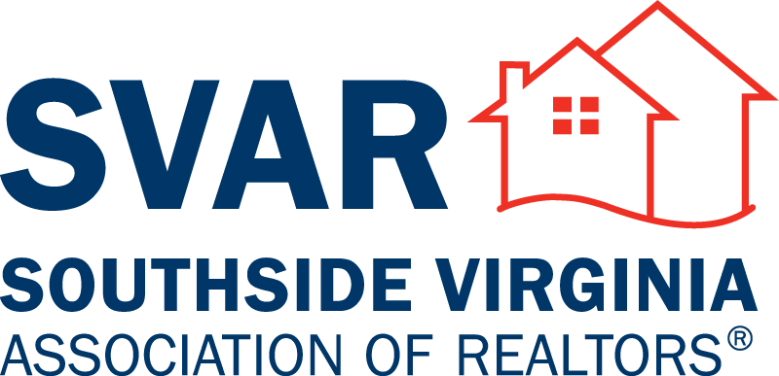

Committee Descriptions

All committee chairs will be appointed by the President-Elect
and approved by the Board of Directors annually by December 31st.

Professional Standards
Members of this committee shall serve for staggered three (3) year calendar terms and must have served on Grievance for a minimum of three (3) years. Therefore, members are typically appointed from Grievance. The purpose of this committee is to hold ethics panel hearings, arbitration hearings and dispute resolution. Annual education is required for this committee.

Grievance
Members of this committee shall serve for staggered three (3) year calendar terms. The purpose of this Committee is to receive, review and advise on complaints of possible violations of the Code of Ethics. Annual education is required for this committee. Criteria for serving may be found in NAR Code of Ethics and Arbitration Manual. Service on this committee for a minimum of three (3) years is required prior to being eligible for the Professional Standards Committee. You must be a REALTOR for at least 3 years to join this committee.

Education
Members of this committee serve one (1) year terms. Members of this committee help to develop educational programs and services that foster ethical and professional behavior and broaden the base of REALTOR® knowledge in areas essential to good and customary real estate practices. Members of this committee also promote fair housing education and other related programs and activities which further fair housing practices and educate and inform the public and REALTORS® on the rights of the general public and obligations of agents, landlords and property sellers. Duties shall also include the operations of the SVAR School.

LDAC
The LDAC committee is comprised of a total of 5 Past Presidents with the Immediate Past-President serving as Chairman. The committee is approved annually by the Board of Directors. The Purpose is to assist in filling vacancies on the Board of Directors either prior to annual elections in October or as needed; identify potential committee and task group chairmen; and recognize and encourage members with leadership potential within the Association. It is recommended that the Current President attend committee meetings as a non-voting member.

Property Management
Members of this committee identify and develop programs to address needs and interests of the property management members of SVAR.

Budget and Finance
Members of this committee have been appointed. The Treasurer will serve a minimum 2- year term. Financials are reviewed on a monthly or quarterly basis. Budget is prepared and presented to the BOD by December for their approval.

Legislative Affairs
Members of this committee are responsible for monitoring local, state and national legislative issues affecting private property rights and real estate related matters. They determine the best use and disbursement of the local RPAC funds available.

RPAC Fundraising
The committee is responsible for raising RPAC funds through annual Association RPAC dues and other programs. The committee shall meet 4 times a year with an overall goal of the Triple Crown.

Community Affairs
This committee will develop programs that will enhance the image of REALTORS®. These programs will focus primarily on providing human and financial capital in areas of need with in the community. In addition, the committee will create the REALTOR Brand and the value of using a REALTOR®.

Preferred Partners
This committee coordinates the activities of SVAR with the resources and support of preferred partner members. Responsibilities also include identifying mutually beneficial opportunities for interaction and business development between REALTORS® and preferred partner members.

DEI (Diversity, Equity, and Inclusion)
This committee will be responsible for creating diverse, equitable, and inclusiveness at SVAR events and activities as well as in the community.

SVAR Networking Group
Members of this group will develop a network of REALTORS and Affiliates that have an interest in uniting all professions that are involved in our industry directly or indirectly.

Awards Review
Members of this committee oversee the awards review program of the Association including the creation of new awards, the distribution of awards materials, verification, selection and presentation to recipients.

Special Events
Members of this committee are responsible for the oversight of special event planning. This committee will ensure that all special events are being planned in accordance with SVAR’s policies and procedures.

Golf Tournament
Members of this committee are responsible for planning of the SVAR charity golf tournament. The committee is responsible for all aspects of the planning and execution of the event.

Fashion Show
Members of this committee are responsible for planning and executing the SVAR charity
fashion show.

Awards Banquet
Members of this committee are responsible for the planning and execution of the annual awards banquet.

*Denotes Standing Committees

Rev: January 17, 2023

